In memory of Terry Bamford – video online
Wednesday 12 May 2021
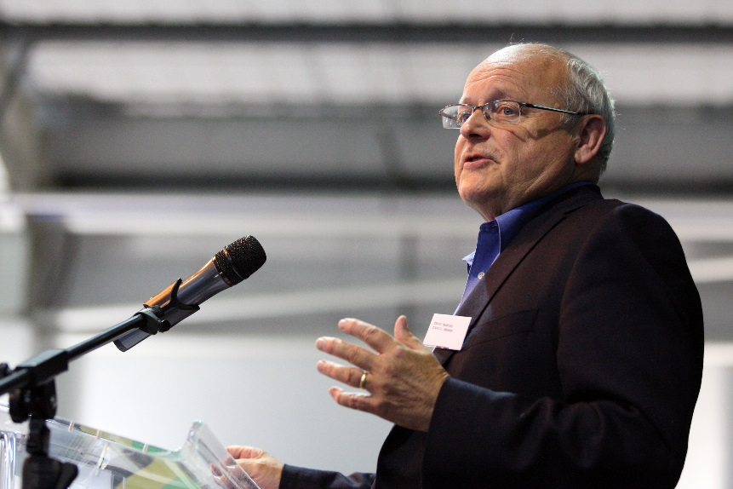
Just over a year ago, on 28 February 2020, family and friends gathered in Worthing to celebrate the life of Terry Bamford.
A memorial event in 2020 was postponed due to the pandemic and instead an online memorial was held on 12 May 2021. The recording of that online event is now available as a YouTube video lasting around two hours.
Terry was a passionate advocate of social justice, international social work and human rights. His contribution to COSW as a founding Board Member, leader, advisor and friend will always be valued. He made a significant contribution to the International Federation of Social Workers as Parliamentarian in General Meetings and on human rights. He was a former Chair of the British Association and had many significant roles throughout his career. Terry has left an enduring legacy and is greatly missed by all who knew him.
The memorial was chaired by Gerry Nosowska (BASW Chair) and speakers included Terry’s wife Margaret (also a social worker), former COSW Chair Charles Mbugua, former IFSW Presidents Sue Dworak-Peck, Elis Envall, Imelda Dodds, David N Jones and Ruth Stark, current IFSW Secretary General Rory Truell, current BASW Chief Executive Ruth Allen and several distinguished guests from politics, social work and other professions.
The video is a tribute to ‘a social worker’s social worker’ (Sue Dworak-Peck) but also an oral history of social policy over six decades.
17 June 2021

