
PRESS RELEASE
6 November 2022

COSW convenes first online Policy Forum
22nd OCTOBER 2022
06.00 - 07.30 and 16.00 – 17.30 (UTC)

COSW held its first ever online and interactive meeting on Saturday 22nd October 2022 for social workers and students in the Commonwealth, national associations, universities and anybody else who wishes to support COSW activities There were two open meetings so people from all time zones could choose the best time for them. Over 60 people from all regions of the Commonwealth participated in each meeting.

The Policy Forum is the first time that COSW has engaged in a wider consultation among the supporters of social work across the Commonwealth. The participants heard about the COSW activities and achievements in detail and considered plans for the future. Messages of encouragement were received from Joachim Mumba (IFSW President) and Annamaria Campanini (IASSW President). Participants were encouraged to ask questions and make comments. The Policy Forum provides advice and guidance to the COSW Board.

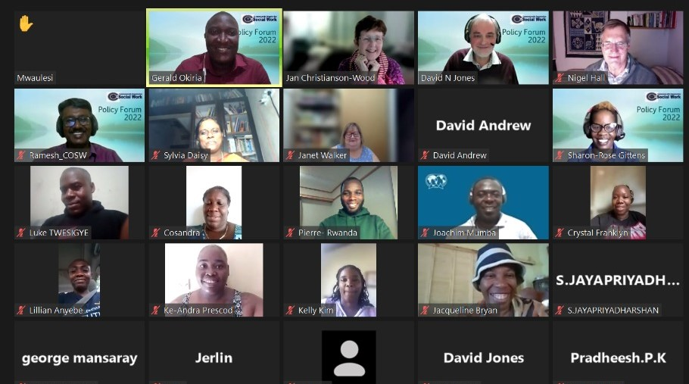
COSW Board members and some of the participants in the second online meeting for North America, Caribbean, Europe and Africa – including Honoured Commonwealth Social Work awardee Nigel Hall

Honoured Commonwealth Social Worker awards were made to Anthony Tan (Malaysia), Terry Bamford (UK), Fiona Robertson (Aotearoa New Zealand), Nigel Hall (UK and formerly Zimbabwe) and Tiong Ngoh Tan (Singapore). Citations will be published on the COSW website.

Continued/…………
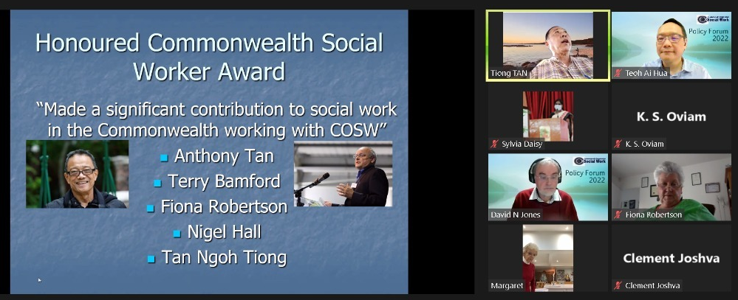

COSW Chair with those receiving an Honoured Social Worker award in the first online meeting
(for Australasia, Pacific, Asia and Europe) – Margaret Bamford (for Terry), Fiona Robertson and Tiong Tan

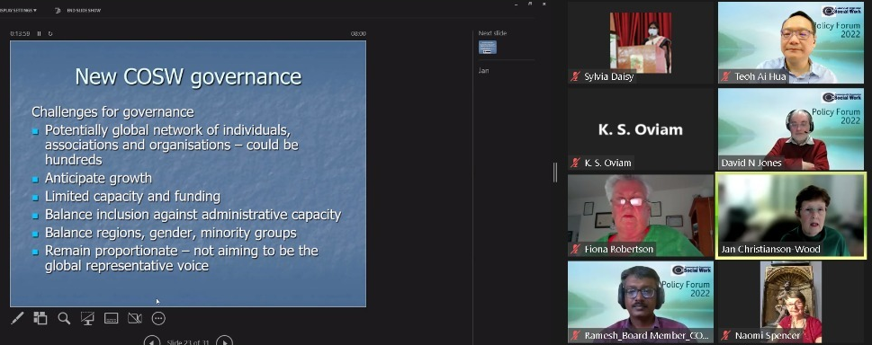
The new constitutional structure of COSW, outlined in the Activity Report, was unveiled and will be implemented over the next two years, enabling full participation of all 56 Commonwealth countries and territories.
COSW Chair with Board Members Ramesh, Jan and David explaining the new governance structure

Reflecting on the event afterwards, COSW Chair Sylvia Daisy observed: ‘COSW sees the people’s Commonwealth as a space for global co-operation and individual interaction, working closely with IFSW, IASSW and other global partners. The participation of around 250 colleagues from all parts of the Commonwealth was exciting and an encouragement to COSW to continue shaping its activities and strategies so that it better reflects real world needs; we are very grateful to IFSW for providing the Zoom platform, support and assistance As we implement our new, more open and inclusive governance structure, we invite interested persons to join hands with us to make the Commonwealth a better place to live - with nobody left behind.’

Sylvia Daisy Romanus [COSW Chair]

NOTE TO EDITORS
COSW is an organisation for citizens of the Commonwealth who are interested in supporting social work and social development. It is supported by social work associations in the Commonwealth. It aims to promote and support communication and collaboration between social workers and social work associations of Commonwealth countries, and to uphold and promote the code of ethics of the International Federation of Social Workers. This statement can be found on the COSW website www.cosw.info/cosw-news

Contact David N Jones +44-1604-414345 ComSocWk@aol.com Twitter @CwlthSocWk

